No | Menu/Submenu | Label | Message | Edit
1. | Contact Us | Send Email success | Your message is successfully sent.  Click here to try again
1. | Contact Us | Send Email error | Your message is not successfully sent.  Click here to try again
2. | Event | Status RSVP | RSVP-ed for Attending, RSVP-ed for Not Attending
3. | Host An Event | Event berhasil dibuat | Event is successfully created.  Click here to view this event.
3. | Host An Event | Event gagal dibuat krn kesalahan teknis,  ex : database error | Muncul halaman error.  *Contoh dibawah.
4. | Find A friend | User belum sign in | You must sign in first to find your friend.
5. | Add as friend | Berhasil nge-add | Request has been sent.
5. | Add as friend | Gagal nge-add | Muncul Alert dengan pesan Error.  *Contoh alert dibawah
6. | Notification | Request Friend | ‘Nama Orang’ wants to be your friend.
7. | Unfriend | Pesan konfirmasi | Are you sure to remove this person from your friend?
7. | Unfriend | Sukses Unfriend | Muncul link add as friend lagi
7. | Unfriend | Gagal Unfriend | Muncul Alert pesan Error.
8. | Notification | Unfriend | ‘Nama Orang’ has removed you from being his friend.
9. | Confirm friend | Accept pesan konfirmasi | Are you sure to confirm this friend request?
9. | Confirm friend | Accept success | You have accepted ‘Nama orang’ ‘s friend request
9. | Confirm friend | Reject pesan konfirmasi | Are you sure to reject this friend request?
9. | Confirm friend | Reject success | You have rejected ‘Nama orang’ ‘s friend request
9. | Confirm friend | Gagal | Muncul Alert pesan Error.
10. | Notification | Accept friend request | ‘Nama orang’ has accepted your friend request.
11. | Notification | Reject friend request | ‘Nama orang’ has rejected your friend request.
12. | List Friend | 0 friend | You don't have any friends.
13. | Send Message | Nama User Tujuan tidak ada di database | No user has name ‘usertujuan’.  Click here to send message again.
13. | Send Message | User tujuan bukan friend | Your message is not succesfully sent. Recipient is not your friend.  Click here to send message again.
13. | Send Message | Nama user tujuan lebih dari satu. | More than 1 of your friends that have name ‘usertujuan’.  Use autocomplete to spesify your friend.  Click here to send message again.
13. | Send Message | Send Message gagal krn error database | Muncul halaman error
13. | Send Message | Send Message berhasil | Your message is succesfully sent.
14. | Notification | User tujuan yang nerima pesan | ‘pengirim’ send you a new message.
15. | News | Admin : Pesan konfirmasi delete news | Are you sure to delete this news?
15. | News | Error delete news (database) | Muncul halaman error : ‘Error delete news’
15. | News | News kosong | No any news
15. | News | Edit News : field title kosong | Error field title must not be blank.  Click here to try again.
15. | News | Edit News : gagal simpan ke database | Muncul halaman error : ‘Error update news on database’
15. | News | Edit News : success | News is successfully updated.  Click here to view this news.
15. | News | Validasi : title ga boleh kosong | Please enter a title for this news
15. | News | Validasi : content ga boleh kosong | Please insert the content
15. | News | Add News : field title kosong | Error field title must not be blank.  Click here to try again.
15. | News | Add News : gagal simpan ke database | Muncul halaman error : ‘Error insert news on database.’
15. | News | Add News : success | News is successfully added.  Click here to view this news.
16. | Edit Profile | Edit basic info : error input data | An Error occurred with your data input.  Please try again.
16. | Edit Profile | Edit basic info : success | Your Basic Info has been successfully updated.  Click here to view your profile.
16. | Edit Profile | Edit location : error updating location | Error updating your location.  Click here to try again.
16. | Edit Profile | Edit location : success | Your location has been successfully updated.  Click here to view your profile.
16. | Edit Profile | Edit education : error input data | Error input data : you still have blank field required.  Click here to try again
16. | Edit Profile | Edit education : success | Your Education has been successfully updated.  Click here to view your profile.
16. | Edit Profile | Edit working : error input data | Error on input data : Field company must be not blank.  Click here to try again.
16. | Edit Profile | Edit working : success | Your Working Experience has been successfully updated.  Click here to view your profile.
16. | Edit Profile | Edit visibility : error input data | Error updating your visibility status.  Click here to try again.
16. | Edit Profile | Edit visibility : success | Your visibility status has been successfully updated.  Click here to view your profile
17. | Sign In | Email password ga cocok | Email and password doesn’t match.
 |  | Ada email lebih dari 1 | More than 1 user with the same email.
18. | Forget Password | Email birthdate ga cocok | No user with email ‘emailnya’ and birthdate ‘ttl’.  Click here to try again
18. | Forget Password | Error database | Something error with our database.  Click here to try again.
18. | Forget Password | Email gagal dikirim | Email can’t be sent to your email.  Click here to try reset password again.
18. | Forget Password | Success | We have send a random generated password to ‘emailnya’ , please check your email and sign in again using that password.
18. | Forget Password | Isi Email forget password | From : Admin Web Alumni Santa Ursula  Subject : Santa Ursula Alumni WebSite - Generated Password  Message:  Dear ‘name’,  You have requested password reset. Now you can login using the password below.  Password : aHyK1kI  Note : please change this random password to protect your security.
19. | Sign Up | Birthdate ga cocok | Please try to remember your birthdate.
 |  | Email sudah dipakai | Email ‘emailnya’ already used.
 |  | Kirim email verifikasi sukses | Success.  Please check your email for email verification.  Click link on the email to complete registration process.
 |  | Setelah klik link verifikasi | Registration is completed.  Click here to sign in.
 |  | Isi email verifikasi | From : Admin Web Alumni Santa Ursula  Subject : Santa Ursula Alumni WebSite - Email Verification  Message:  Dear ‘name’,  Thanks for becoming our member. To finish your registration process please click the link below.  http://aaaaababbabababab.....
Note : kalau mau edit tandain ya mana yang diedit. Habis cek lagi kayaknya masih banyak yang ngacau pesan2nya, tolong dikoreksi..
Contoh halaman error :
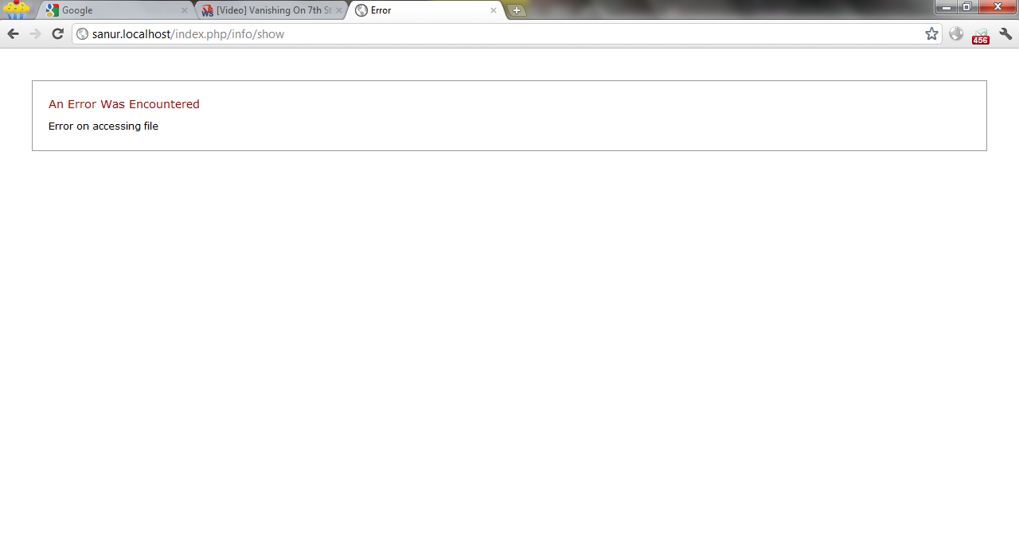

Error yang seperti ini buat kesalahan yang teknis, ex : database error, server error, error accessing file, error accessing page.
Untuk error kesalahan ‘human’, ex : input kurang, input data field error, input ga ‘match’ seperti ini,
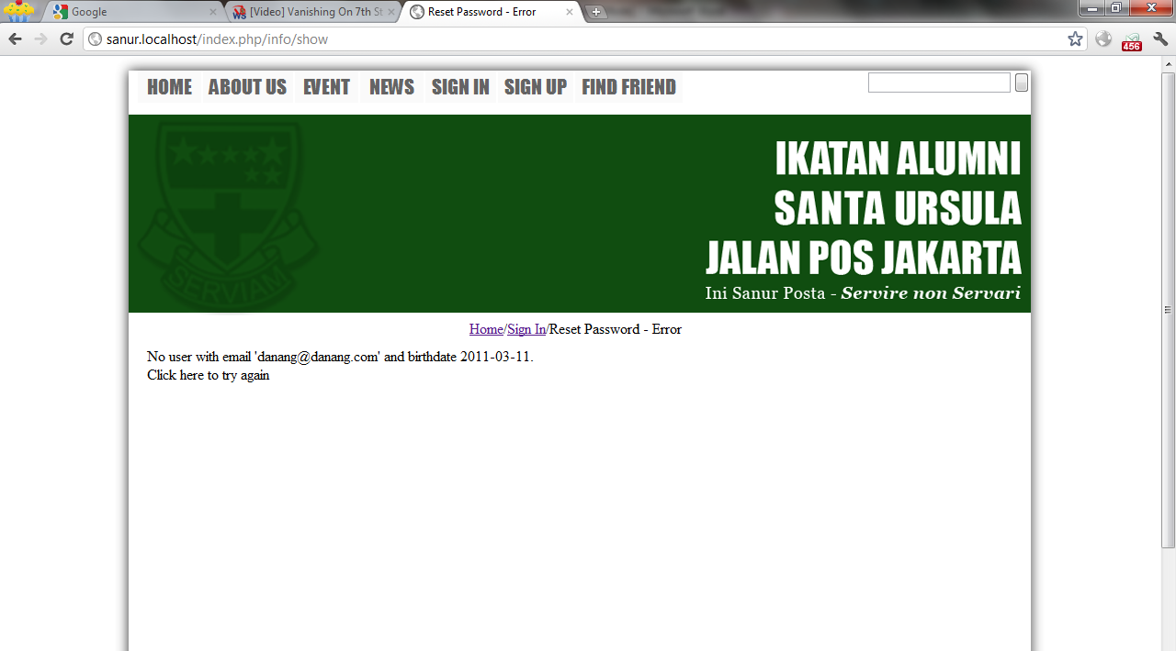
Contoh alert error :
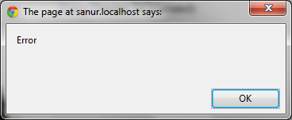
Penggunaan alert error masih buat gampangnya aja sih, kalo ada ide biar bagusnya gimana, note’in aja.

